## User Stories

* As a junkyard owner, I want to quickly register new vehicles that arrive into my yard based on make and model, so I don’t have to manually keep track of which ones.
* As a junkyard owner, I want to quickly catalog all available parts for a new vehicle, so I will have a record of parts that I can sell later.
* As a customer in need of a spare part, I want to search for a specific part by entering my car's make, model, year, and part type, so that I can immediately see if an exact match or compatible part is available.
* As a junkyard owner, I want to finalize the sale of a part by marking it as sold and removing it from stock, so that my inventory stays updated and it can’t be purchased again.

## Objects

* Junkyard - Information including physical address and contact information
* Car - Information about the car like vin, make, model, year, and color along with make/model years start/end for easy compatibility lookups
* Part - information about the specific part like part number, description, an optional color field along with sale price and time (to be filled out during sale)
* Price History - information about the price change for a part

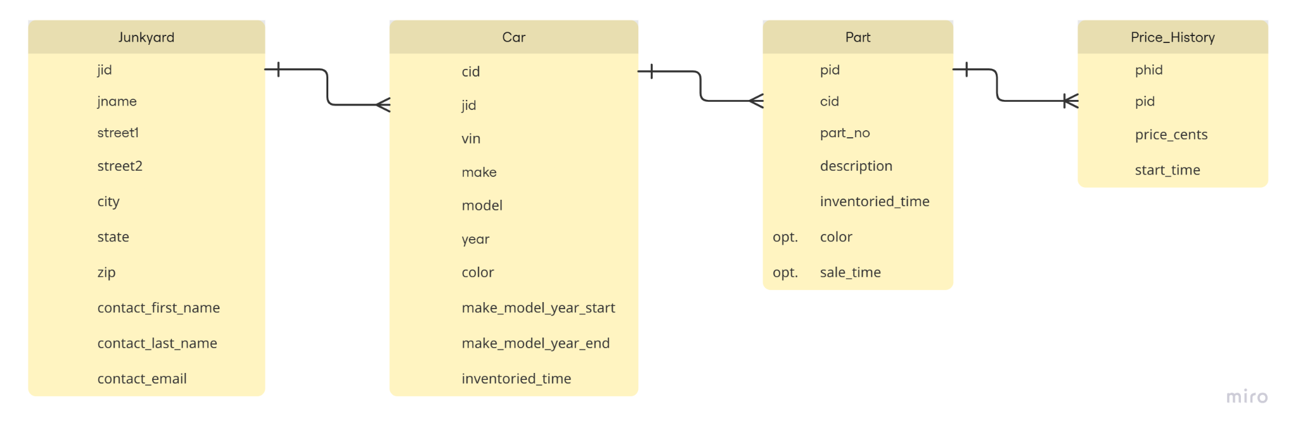

## Events

* [Internal] Add Junkyard - creating a new junkyard
* [Internal] Add Car - adding a new car when it comes to the junkyard
* [Internal] Add Part - this will be the most common event as there will be many parts to be inventoried once a new car comes into the junkyard
* [Internal] Add Price - adding a price for a specific part
* [Customer] Search for Part - Customer can type in their make, model, year, and part they’re looking for
* [Internal] Sell Part - when a part is sold, we want to timestamp and remove it from inventory